E-LEARNING SCHEMA

**ER DIAGRAM**

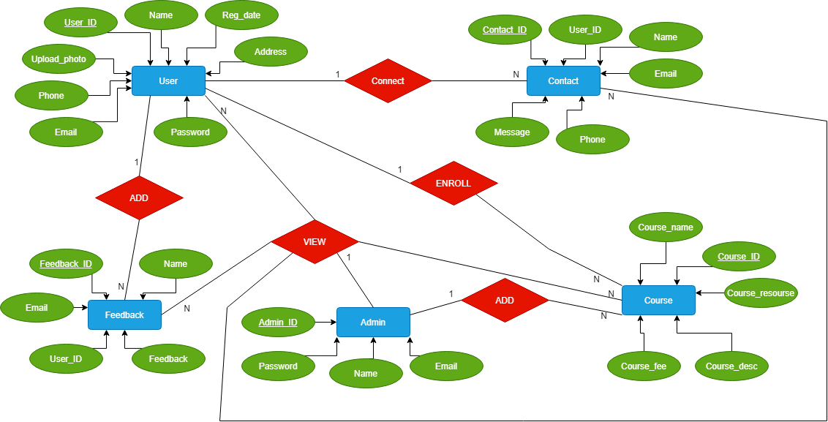

**CREATING E-LEARNING SCHEMA**

**Step 1: Connect to database**

conn system/password

**Step 2: Create tablespace**

CREATE **TABLESPACE** tbs_register DATAFILE 'tbs_register.dat' SIZE 1M AUTOEXTEND ON;

**Step 3: Create a new user in Oracle**

CREATE **USER** elearning IDENTIFIED BY learning123 DEFAULT TABLESPACE tbs_register QUOTA unlimited on tbs_register;

**Step 4: Grant permissions**

GRANT create session TO register;

GRANT create table TO register;

GRANT create sequence TO register;

**Step 5 : Create USER1 table**

Create tables and sequences

create table user1(user_id number primary key,name varchar2(100),phone_no number,email varchar2(100),address varchar2(100),reg_date date,password varchar2(100),upload_photo long);

create sequence userid start with 100 increment by 1;

insert into user1(user_id,name,phone_no,email,address,reg_date,password,upload_photo) values(userid.nextval,'Ankit',4578008234,'ankit@gmail.com','noida','03-jan-2021','ankit','img.jpg');

insert into user1(user_id,name,phone_no,email,address,reg_date,password,upload_photo) values(userid.nextval,'Rahul',9586234712,'rahul@gmail.com','banglore','03-mar-2021','rahul','img1.jpg');

insert into user1(user_id,name,phone_no,email,address,reg_date,password,upload_photo) values(userid.nextval,'gouthami',8524379162,'gouthami@gmail.com','anantapur','03-feb-2021','gouthami','img2.jpg');

insert into user1(user_id,name,phone_no,email,address,reg_date,password,upload_photo) values(userid.nextval,'iswarya',9256279162,'iswarya@gmail.com','nellore','22-feb-2021','iswarya','img3.jpg');

insert into user1(user_id,name,phone_no,email,address,reg_date,password,upload_photo) values(userid.nextval,'harshitha',7456279162,'harshitha@gmail.com','vijayawada','22-jan-2020','harshitha','img4.jpg');

commit;

Select * from user1;

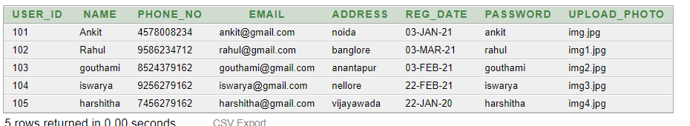

**Step 6 : Create CONTACT table**

create table contact(user_id number references user1 , name varchar2(30), Email varchar2(20), Phone_no number, Messege varchar2(20), contact_id number primary key);

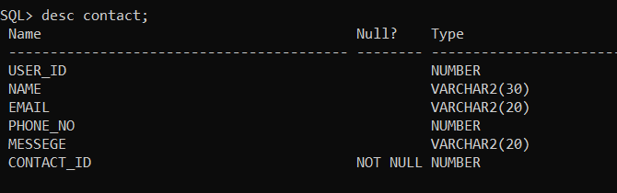

insert into contact values (101, 'Ankit', 'ankit@gmail.com', 1234, 'Message',1);insert into contact values (102, 'Rahul', 'rahul@gmail.com', 1235, 'Message',2);insert into contact values (103, 'Gouthami', 'Gouthami@gmail.com', 1236, 'Message',3);insert into contact values (104, 'Ishwarya', 'Ishwarya@gmail.com', 1237, 'Message',4);insert into contact values (105, 'Harshitha', 'Harshitha@gmail.com', 1238, 'Message',5);

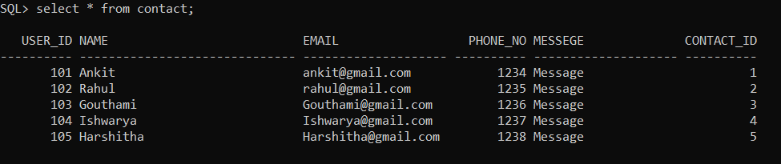

**Step 7 : Create ADMIN table**

create table admin ( admin_id number primary key, name varchar2(100),email varchar2(100), password varchar2(100);

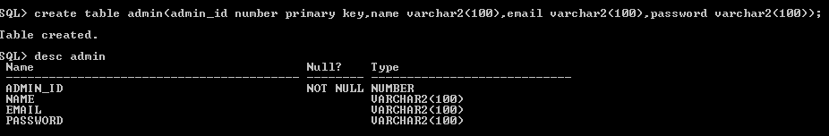

insert into admin values (1,’rahul’,’rahul@gmail.com’,’pass’);

insert into admin values (2,’ankit’,’ankit@gmail.com’,’pass’);

insert into admin values (3,’gowthami’,’gowthami@gmail.com’,’pass’);

insert into admin values (4,’aishwarya’,’aishwarya@gmail.com’,’pass’);

insert into admin values (5,’harshitha’,’harshitha@gmail.com’,’pass’);

Select * from admin;

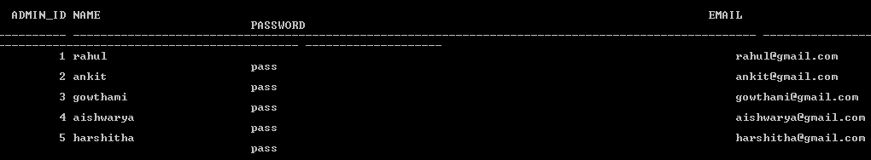

**Step 8: Create COURSE table**

create table course ( course_id number primary key, c_name varchar2(100),c_desp varchar2(100), c_fees varchar2(100),c_resource varchar2(100));

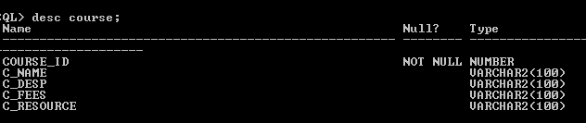

insert into course values (111,’JAVA’,’Programing language’,299, ’video.mp4’);

insert into course values (112,’C Programming’,’Programming language’,199, cprogram.mp4’);

insert into course values (113,’C++ Programming’,’Programming language’,199, c++program.mp4’);

Select * from course;

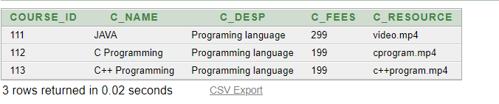

**Step 9: Create FEEDBACK table**

create table feedback(user_id number references user1,name varchar2(100),email varchar2(100),f_id number primary key,feedback varchar2(100));

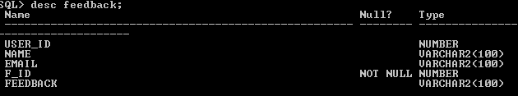

insert into feedback(user_id,name,email,f_id,feedback)values(101,'ankit','ankit@gmail.com',1,'good');

insert into feedback(user_id,name,email,f_id,feedback)values(105,'harshitha','harshitha@gmail.com',2,'good');

select * from feedback;

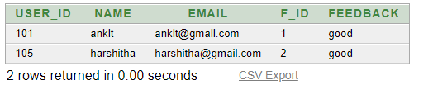

# REGISTRATION FORM

User ID

Name

Email

Password

Phone

Address

**UPLOAD**

Upload Photo

**REGISTER**

# CONTACT FORM

USER ID

NAME

E-MAIL

PHONE

MESSAGE

**SUBMIT**

# FEEDBACK FORM

Name

User ID

Email

Feedback

**SUBMIT**

# COURSE FORM

Course ID

Course Name

Course Description

Course Resources

**UPLOAD**

Course Fees

**SUBMIT**